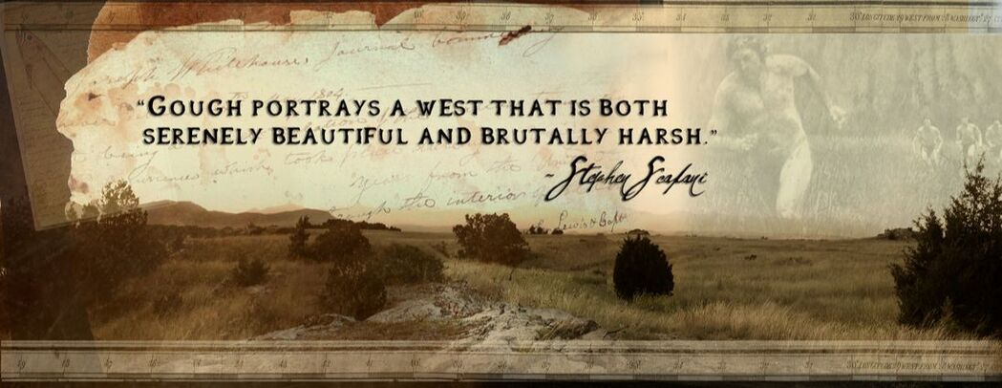

**The Logline:  
One resolute man defiantly challenges an unforgiving Rocky Mountain wilderness,  
 braving the Blackfoot Nation intent on his destruction and their own preservation.  
​**

The screenplay of *Colter's Run* is based on the novel of the same name ~ both written by Stephen T. Gough.  It is a historical account based on actual events and characters.

*"... the potential “story” enclosed within the pages of your book****“Colter’s Run”****makes that  
of Hugh Glass in “****The Revenant”****pale in comparison and gives rise to the notion of what  
​putting John Colter’s story in that venue might accomplish."*

February 1, 2016  
An Open Letter from *Colter's Run*  Publisher,  Dale A. Burk, Stoneydale Press  
  
While the part of Glass’ life portrayed in *The Revenant*  is dramatic and a focus on the grit, the resonance of a time, and Glass’ persistence on the personal achievement of revenge for a wrong done him, it pales in comparison to the grand sweep of John Colter’s life story – not only including his dramatic “run” from the Blackfeet when they captured him and John Potts, but John Colter’s survival and ultimate triumph over that and other threats to his life in several ways personifies the essence of that time in American history as a young nation swept westward to fulfill a mandate that ultimately came to be known as the ‘Manifest Destiny.”  
  
The key, of course, is that John Colter’s short period of time in the West fundamentally centered on the Three Forks area at the head of the Missouri River located in what is now known as Montana, literally was epochal. First, he was part and parcel of the initial thrust of the United States into the western part of the continent as a key member of the Lewis & Clark’s Corps of Discovery in 1804-06. That he left the Corps on its return to the east on its way home in 1806 to stay and trap in the headwaters of the Missouri is vital; in so doing, he unwittingly became a centerpiece of the subsequent intrusion of the American expansion into the fur-rich upper Missouri. He subsequently led several trapping excursions into the area; he became conversant with the various Indian nations present in that historic dialogue, including the Crow, the Shoshone, the Salish (also called the Flatheads), and, of course, was personally identified by the Blackfeet as one of their primary enemies as a result of the 1808 battle above the Three Forks so eloquently outlined in your book. In short, I recall an element of Colter’s story that is profound. When asked why he kept going back into the rich trapping waters of the Missouri headwaters in the Three Forks area where he knew death at the hands of the Blackfeet was not only possible but most likely inevitable, he replied with the words that “No man will call me a coward”and only when he satisfied himself that he had faced up to that internal need to prove himself worthy of his own estimation of what sort of a man he really was did he leave the frontier. Thus, wrapped up within the person of John Colter is not only an individual story of incredible commitment to self-respect as a man living in changing and perilous times, but that of a person whose very presence at the forefront of that period of our history demonstrates the greatness if not the uniqueness of John Colter in the “lived out” history of his times. And it’s my conviction that your story, whether in book or movie form, should portray that grand story and not just that of a man who survived a single, terrible ordeal at the hands of a superior foe. That you accomplished this so well in your book “Colter’s Run” is a major reason we decided to publish your novel in the first place. To close, I repeat author William Ghent’s quote about John Colter you used as the introduction to Part Two of your book: “Of undaunted courage and incredible endurance, his entire career, as far as we know it, was filled with perilous adventure, and his exploits might pass for fairy tales were they not substantiated by the most-reliable evidence.”

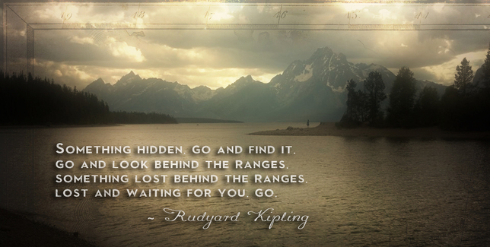

Colter's Bay, Grand Tetons National Park, Wyoming